
AMERICAN INTERNATIONAL UNIVERSITY-BANGLADESH
Faculty of Science and Technology Department of Computer Science CSC 4118: Computer Graphics
Final Term Project Evaluation Semester: Spring 2024-2025 CO Assessed: CO3 Total Marks:

Name: Sadia Mahan Auti | ID: 23-52092-2 | Section: N | SL. | Group No.2

OBE Evaluation:

CO3: Integrate the development of visual and conceptual skills to design solutions through the process of idea development, refinement, and assessment in the creation of real-world projects.
Requirement specification (5) | Design & Implementation (5) | Total Marks (10)

AMERICAN INTERNATIONAL UNIVERSITY-BANGLADESH
Faculty of Science and Technology Department of Computer Science CSC 4118: Computer Graphics
Final Term Project Evaluation Semester: Spring 2024-2025 CO Assessed: CO3 Total Marks:

Name: Sadia Mahan Auti | ID: 23-52092-2 | Section: N | SL. | Group No.2

OBE Evaluation:

CO3: Integrate the development of visual and conceptual skills to design solutions through the process of idea development, refinement, and assessment in the creation of real-world projects.
Requirement specification (5) | Design & Implementation (5) | Total Marks (10)

Table of Contents

1. Introduction ..............................................................…………………….…………………xx
2. Project Graph/Design............................................................................................................. xx
3. Game Levels…………............................................................................................................ xx
4. List of Objects Assigning an Object ID................................................................................ xx
5. List of Functions to Represent Objects ............................................................................... xx
6. List of Animation Functions with ID ................................................................................... xx
7. Output ..................................................................................................................................... xx
8. Mouse and Keyboard Interaction........................................................................................................ xx
9. Conclusion ............................................................................................................................... xx

1. Introduction
The Racer X-City Drift project is a 2D racing simulation game developed using OpenGL and C++. The primary objective of the game is to provide players with an immersive experience of controlling a car while navigating through various environmental conditions, managing weather effects, and competing against AI opponents.
The game’s key features include:
- Lane switching and speed control for the player’s car.
- Real-time weather transitions such as rain, fog, snow, and desert storms.
- Day and night cycles, affecting the visual environment of the game.
- Several opponent cars with varying speeds.
- Interaction via keyboard and mouse, allowing the player to control the car's speed, direction, and toggle weather effects.
The project demonstrates my skills in developing interactive simulations and real-time graphics using OpenGL.

2. Project Design
The project’s design focuses on creating a dynamic and interactive environment that adjusts to various levels, each with unique environmental conditions and challenges. Key elements of the game include:
- Road: Multi-lane roads with dynamic markings and interactive objects.
- Player Car: Controlled via keyboard for lane-switching and speed adjustments.
- Opponent Cars: Moving in different lanes, with varying speeds.
- Environmental Effects: Day/night transitions, weather effects like rain, snow, fog, and interactive lighting systems.
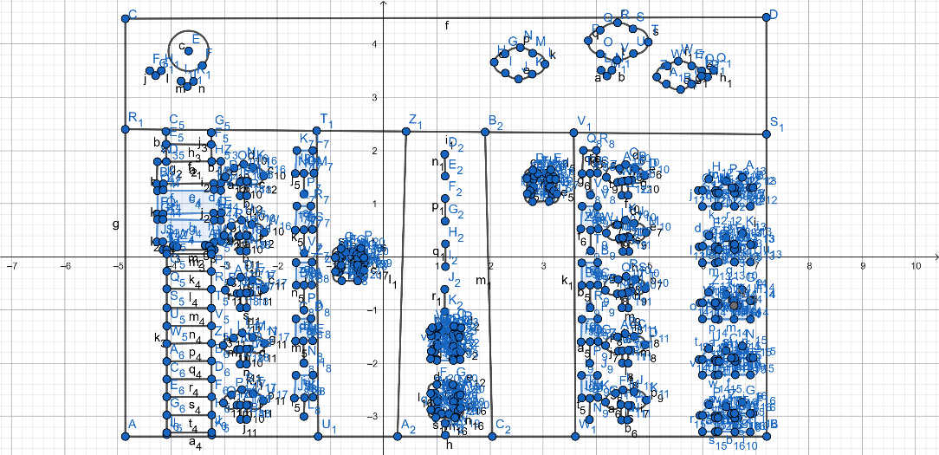
Figure 1: Project Graph plot
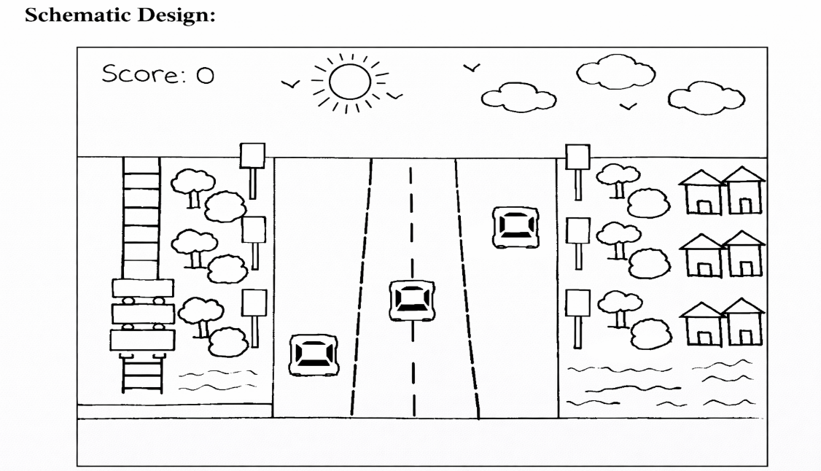
Figure 2: Racing game schematic design

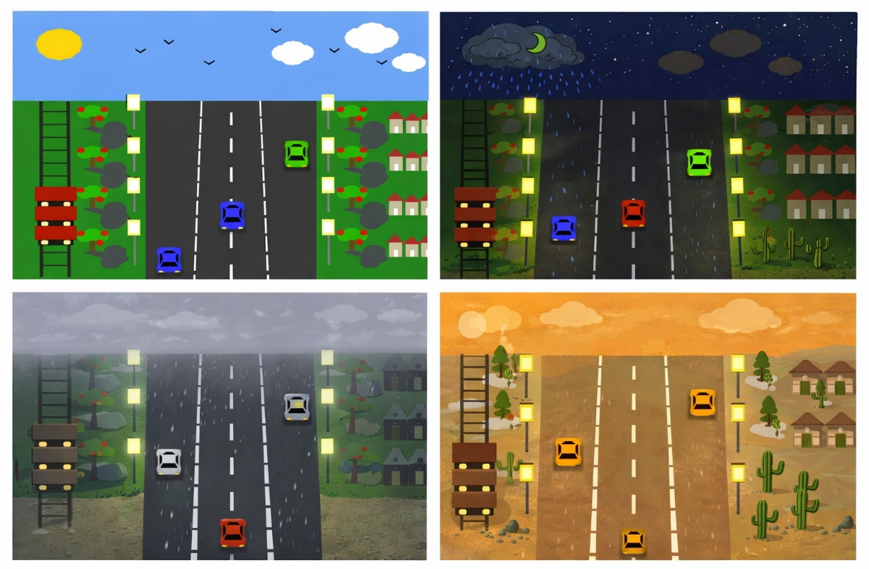
Figure 2: Racing game design
3. Game Levels
The game is divided into multiple levels, each offering unique challenges for the player. The levels are as follows:
- Level 1: Beginner (Rainy): The first level introduces basic gameplay, with the player racing through a road with rainy conditions. It is designed for new players to get accustomed to the controls and gameplay mechanics.
- Level 2: City Rush Hour: This level features a busy city environment with traffic. Opponent cars move faster, and the player needs to navigate through dense traffic while maintaining control over the car's speed and direction.
- Level 3: Foggy Mountain: The third level introduces a foggy mountain setting, where visibility is reduced, making it challenging for the player to avoid obstacles and other cars. This level emphasizes the importance of careful navigation and slower speeds.
- Level 4: Snowy Peaks: In this level, the player races through snowy terrain with slippery roads. The snow affects the player's car handling, and the goal is to reach the finish line while managing the challenging weather conditions.
- Level 5: Desert Highway: The final level takes place on a desert highway, where dust storms reduce visibility. The road is narrower, making it more difficult to maneuver, and the speed of the opponent cars increases significantly.

4. List of Objects Assigning an Object ID
SL# | Object ID | Object Name
1 | ROAD | Road
2 | PLAYER_CAR | Player Car
3 | OPPONENT_CAR | Opponent Car
4 | TREE | Tree
5 | LAMP | Lamp
6 | HOUSE | House
7 | SKY | Sky
8 | RAIN | Rain
9 | BIRD | Bird
5. List of Functions to Represent Objects
SL# | Function Name | Object ID
1 | drawRoad | ROAD
2 | drawPlayerCar | PLAYER_CAR
3 | drawOpponentCar | OPPONENT_CAR
4 | drawTree | TREE
5 | drawLamp | LAMP
6 | drawHouse | HOUSE
7 | drawSky | SKY
8 | drawRain | RAIN
9 | drawBird | BIRD

6. List of Animation Functions with ID
SL# | Animation Function | Animation Function ID
1 | movePlayerCar | PLAYER_CAR
2 | moveOpponentCars | OPPONENT_CAR
3 | moveRain | RAIN
4 | moveBirds | BIRD
5 | changeDayNight | SKY
6 | changeWeather | SKY
7 | animateCars | OPPONENT_CAR
8 | animateTreesAndHouses | TREE, HOUSE

7. Output
The game features dynamic environmental transitions across all five levels:
- Day Mode: The road and cars are illuminated with natural lighting, clear skies, and normal weather conditions.
- Night Mode: The road is dark with headlights illuminating the way, and the night sky is visible with stars and a moon.
- Heavy Rain: The environment is affected by rain, reducing visibility and adding difficulty to the gameplay.
- Desert Storm: A dust storm affects the player's visibility and the speed of vehicles on the road.
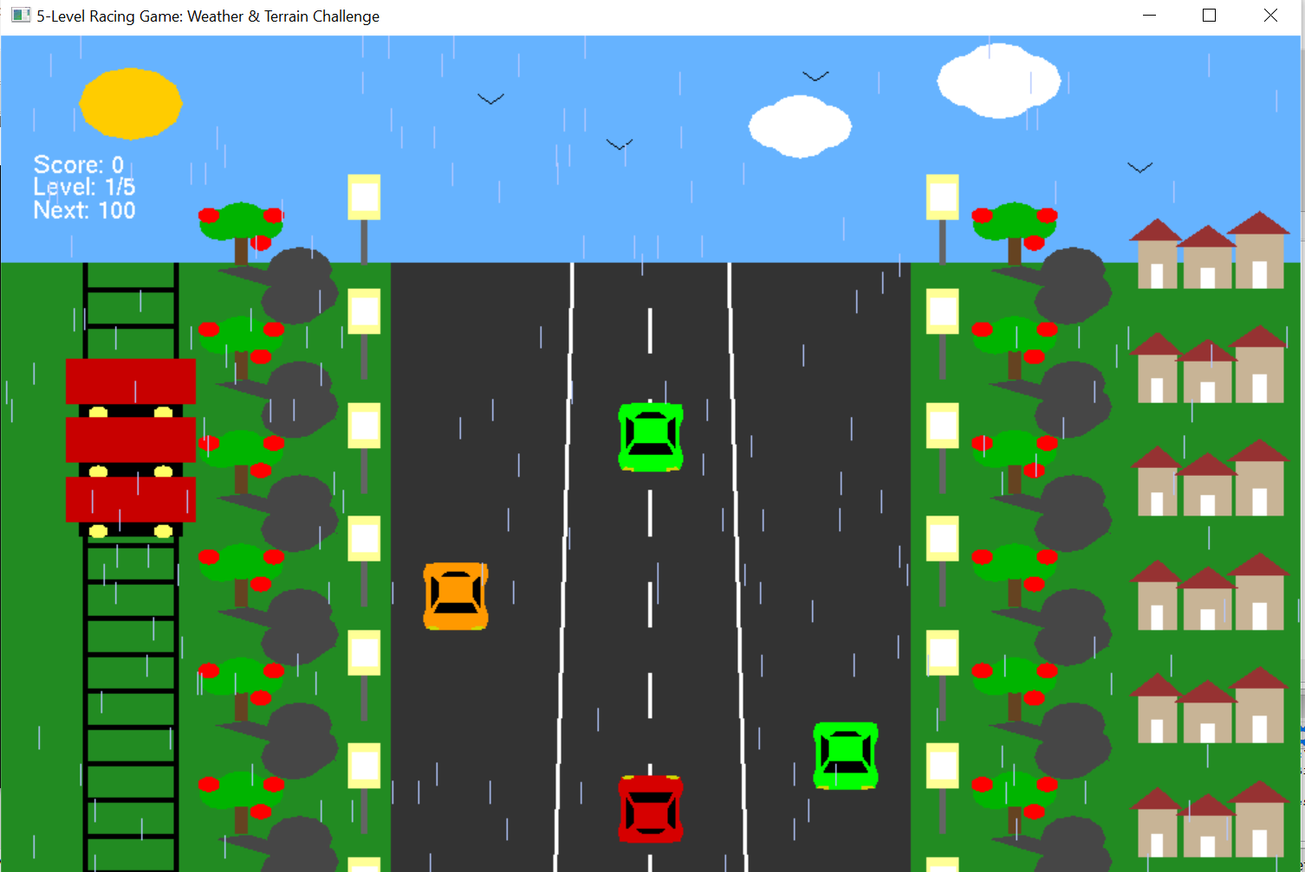

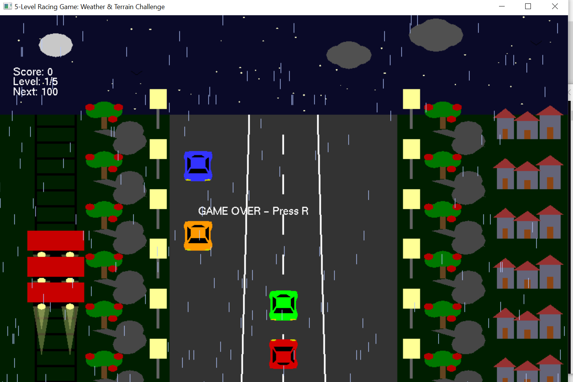
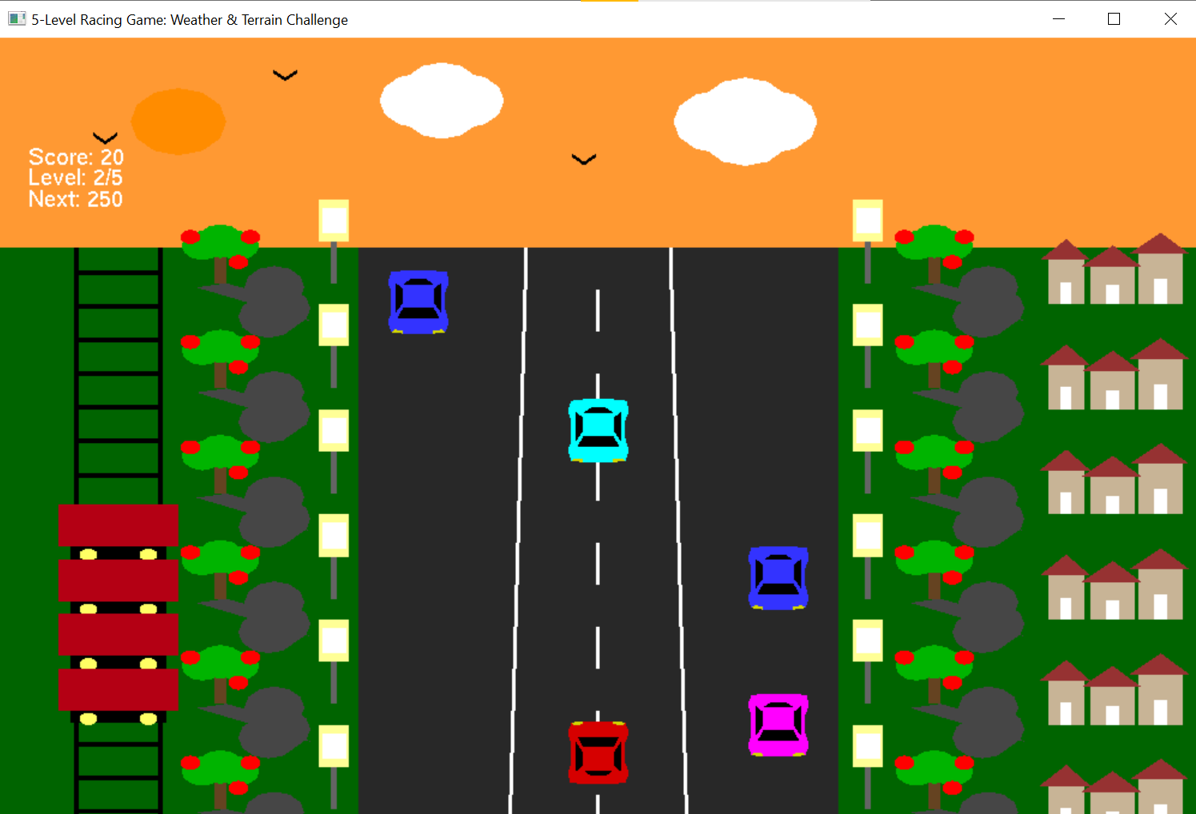
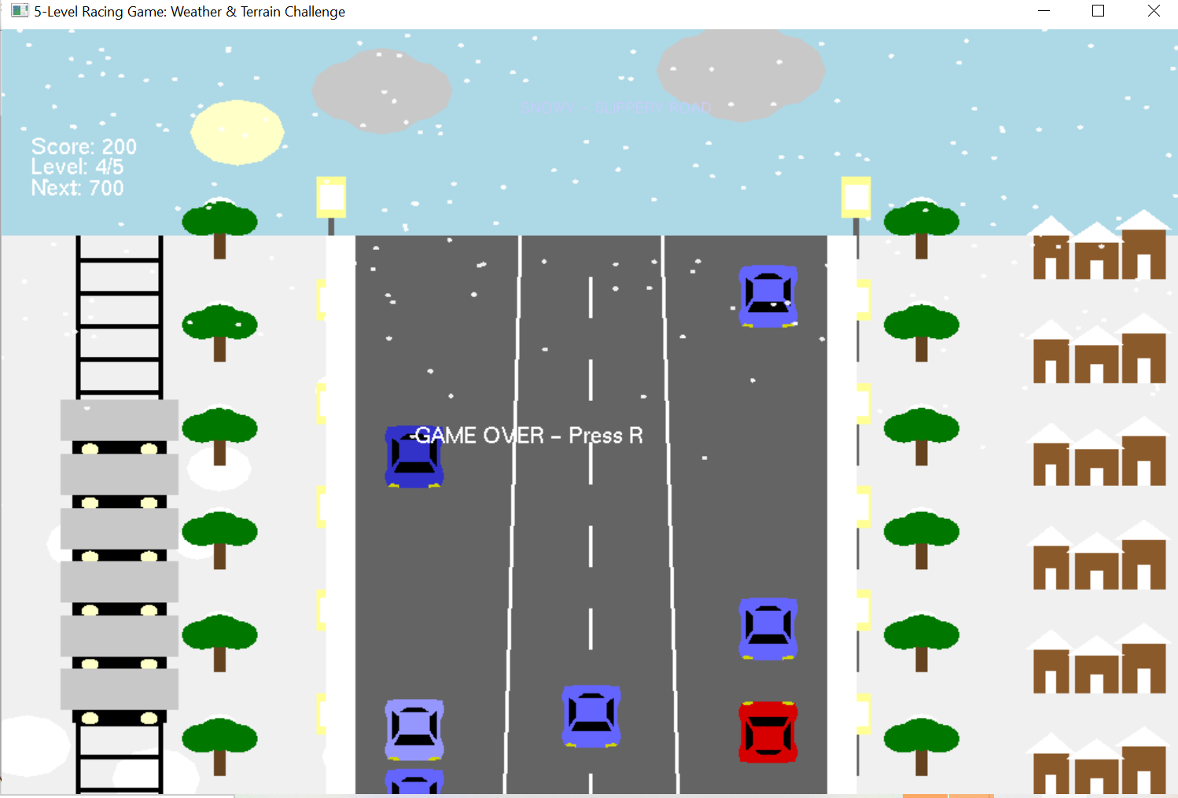
8. Mouse and Keyboard Interaction
- Mouse Interaction:
  - Mouse Left-click: Pause/resume the red car.
  - Mouse Right-click: Pause/resume the night train.
- Keyboard Interaction:
  - D / N key: Toggle between Day/Night mode.
  - Arrow Up/Down: Control the speed of the player’s car during day mode.
  - Arrow Left/Right: Control the car’s direction during the day.
  - W / S keys: Control the player's car movement up or down the track.
  - A / D keys: Control the player’s car lane-switching.
  - H: Toggle heavy rain conditions.

9. Conclusion
The Racer X-City Drift project successfully integrates various computer graphics and game development principles using OpenGL and C++. By developing multiple levels with different environmental challenges, the game offers an engaging and realistic simulation. The project demonstrates my ability to apply geometric algorithms, manage real-time animations, and create interactive environments.
The modular design of the game allows easy extension to new levels, weather effects, and environmental transitions, making it adaptable for future development. The project reinforces key concepts in computer graphics such as object manipulation, state-driven rendering, and environmental simulation.

